Symmons Evolution Property Audit Form

Water Flow Monitoring

Instructions

- Please fill out the Property Information below
- Please read Recommended Property Sensor Applications on Page 2
- Please select from one of the two Sensor Types and fill out the applicable Flow Monitoring template for each sensor requested:
  - Water Meter Sensor
  - Clamp-On Pipe Flow Sensor
- Please attach the following documents:
  - Most recent previous two water utility bills
  - Property / Site Layout Plans (can be high-level, physical overview)

Utility Meter Sensor | Clamp-On Pipe Flow Sensor
Sensor straps to the side of an existing water meter and delivers real-time flow data and alerts, 24/7. | Install on any Stainless Steel, Copper, PVC, Iron and Resin pipe, delivering real-time flow data and alerts.
Note: Must Specify Meter Make / Model and if Meter is Compound or Single. | Note: Pipe Outer Diameter must be specified for each location to ensure correct sensor model. Models range from ¼” to 8” pipe sizes.
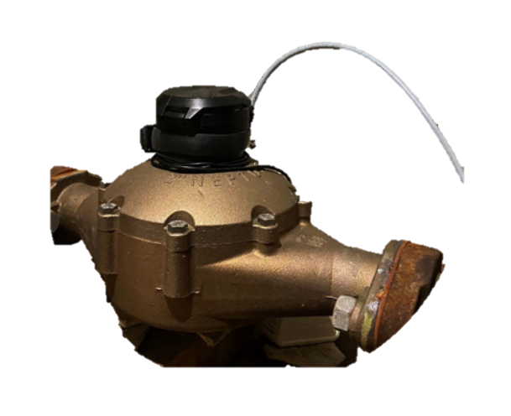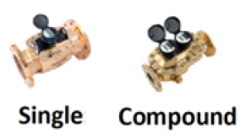 | 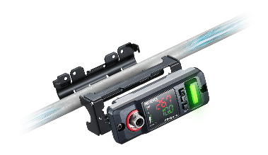

Property Information

Property Name
Property Address
Contact Name
Contact Email
Contact Phone
Quantity: Water Meter Sensor
Quantity: Clamp-On Pipe Flow Sensor

Recommended Property Sensor Applications

About Symmons Evolution

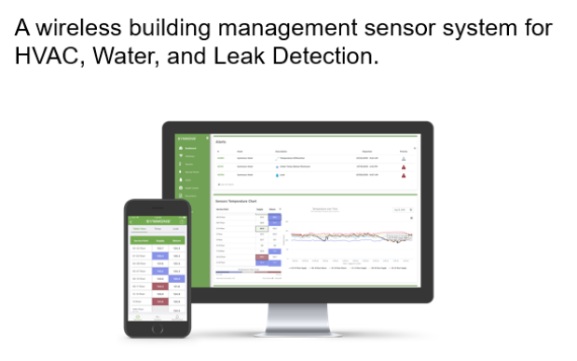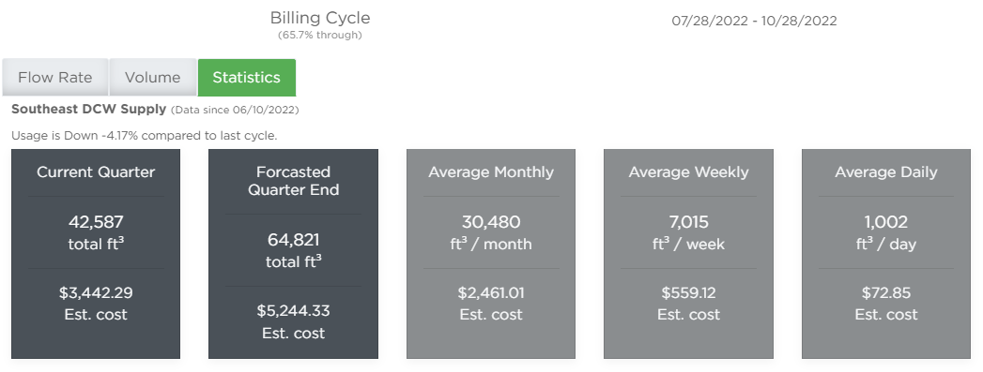

Quick Facts

  - Each Property is assigned a Symmons Customer Success Manager who remotely onboards, trains, manages facility alerts and follows up on a monthly basis to review site anomalies and assets areas to address issues and save water.
  - All sensors wirelessly communicate to a Symmons Evolution Cellular Gateway (Verizon or AT&T), typically 2-4 Gateways needed per facility depending on size and number of buildings (>1 mile connectivity line-of-sight). Wireless coverage and sensor up-time is the responsibility of Symmons.
  - All sensors are non-invasive to pipes and meters and require no shutdown.
  - Both the Utility Meter Sensor and Clamp-on Pipe Flow Sensor report the same data: Totalized Water Volume Used and Instantaneous Flow Rate (Cubic Feet and Gallons).
  - Water Utility Bill Estimates, Period Ending Projections and trend data is given for each asset along with SMS, Email, and Emergency 24/7 outbound call service.

Recommended Property Asset Coverage

 | Asset
1 | Main Domestic Water Utility Meters
2 | Cooling Tower Water Supply
3 | Chiller Makeup Water Supply
4 | Restroom Main Water Supplies
5 | Food Courts or Restaurants
6 | Irrigation Systems
7 | Large Tenants / Mixed Use Annex Spaces
8 | Large Fountains

Sensor Flow Monitoring Information

 | Utility Meter Sensors
# | 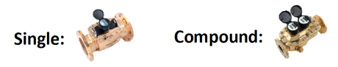
1 | Meter Make / Model |  | Photo of Meter:
 | Single or Compound Meter?
 | Property Location
 | Access to 120 VAC Power? (Yes/No)
2 | Meter Make / Model |  | Photo of Meter:
 | Single or Compound Meter?
 | Property Location
 | Access to 120 VAC Power? (Yes/No)
3 | Meter Make / Model |  | Photo of Meter:
 | Single or Compound Meter?
 | Property Location
 | Access to 120 VAC Power? (Yes/No)
4 | Meter Make / Model |  | Photo of Meter:
 | Single or Compound Meter?
 | Property Location
 | Access to 120 VAC Power? (Yes/No)
5 | Meter Make / Model |  | Photo of Meter:
 | Single or Compound Meter?
 | Property Location
 | Access to 120 VAC Power? (Yes/No)

Please copy template for more sensors.

 | Clamp-On Pipe Flow Sensor
# | 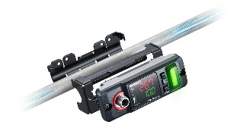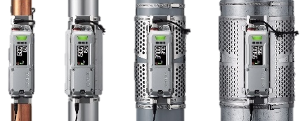
1 | Pipe Outer Diameter (OD)
 | Property Location
 | Is at least 5” length of pipe available for sensor placement? (Yes/No)
 | Access to 120 VAC Power? (Yes/No)
2 | Pipe Outer Diameter (OD)
 | Property Location
 | Is at least 5” length of pipe available for sensor placement? (Yes/No)
 | Access to 120 VAC Power? (Yes/No)
3 | Pipe Outer Diameter (OD)
 | Property Location
 | Is at least 5” length of pipe available for sensor placement? (Yes/No)
 | Access to 120 VAC Power? (Yes/No)
4 | Pipe Outer Diameter (OD)
 | Property Location
 | Is at least 5” length of pipe available for sensor placement? (Yes/No)
 | Access to 120 VAC Power? (Yes/No)
5 | Pipe Outer Diameter (OD)
 | Property Location
 | Is at least 5” length of pipe available for sensor placement? (Yes/No)
 | Access to 120 VAC Power? (Yes/No)

Please copy template for more sensors.

